Accelerated entry into C++14


Romantic memories of awesome architecture (hand coded , relying on discipline, make your own tools)

Real world old school style results

#bugfest

Why do construction workers succeed at anything?


Encapsulation of expertise
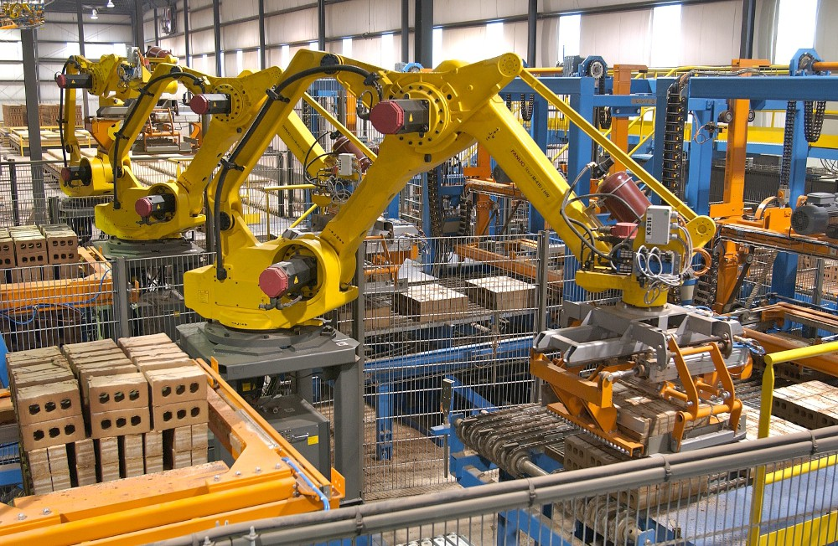

Sheldon like precise description in the flash like speed


Bare metal low level
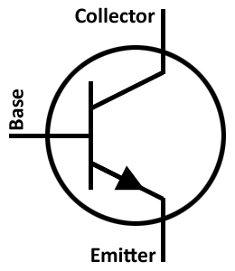
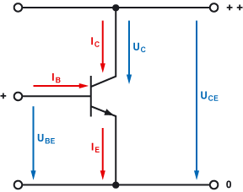


Gates, Flipflops

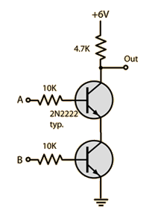
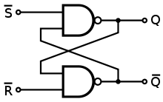
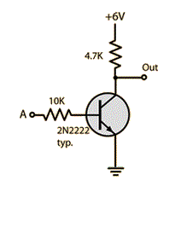

Addressing, RAM
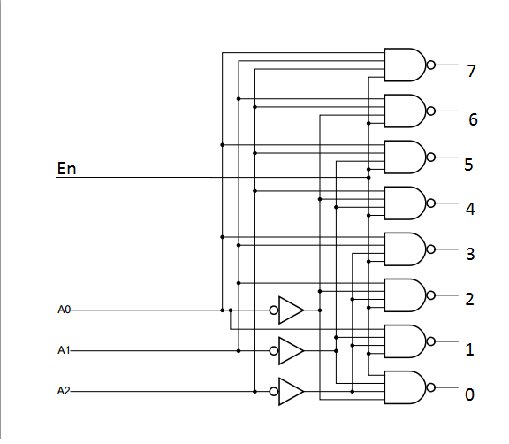

Processor

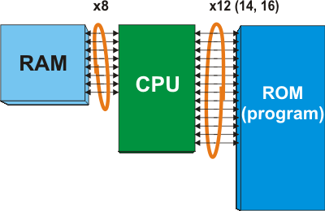

Assembler
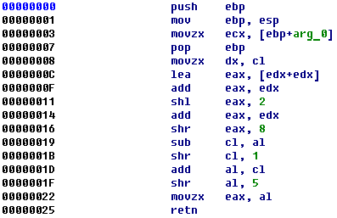
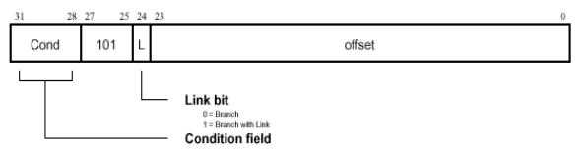

Assembler 2
- simple commands like add, branch, xor, move etc.
- different commands for each processor
- even a simple program can be millions of lines of code!
- memory access done by hand!

Compiler
- translates code from a higher level programming language into assembler
- keeps track of memory automatically*
- can translate the same code into assembler for different processors
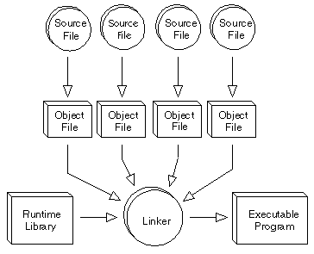

C the original sin of C++

- C is a subset of C++
- There is nothing C can do which C++ cannot
- C is missing mechanisms used for safety checks
- C is missing mechanisms for generic code
- C is missing mechanisms for zero cost abstraction
- You can write bad code in both C and C++ but its often impossible to write good, safe library code in C
- There is a myth that C is more efficient which is propagated exclusively by those who cannot program well in C++

Types vs. Values
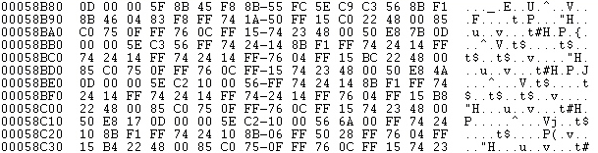
Types:
- contain information about the interpretation of data
- type information is used by the compiler in order to generate the correct code
- type information often decides which overload (version) of a function is used when manipulating data
- contains the size (in bytes) of the data

Data is just raw bits

Low level data types in C++:
bool: used to represent a true/false value. Actually uses more than one bit.
int / long: used to represent whole numbers.
float / double: used to represent floating point numbers.
enum class: used to represent lists of things which are not numbers (but are encoded as numbers)
char: used to represent letters and typographical symbols
string: used to represent strings of letters (words, sentences etc.)

Real code:

int i{ 4 };
i += 7;
double d{ 100.42 / i };
bool b{ d > i };

enum class CatName { Garfield, Fuzzy, KickMe };
enum class KidName { Bob, Joe, KickMe };
CatName cat{ CatName::KickMe };
KidName kid{ KidName::KickMe };
cat = i; //error
cat = kid; //error

char c{ 'a' };
std::string s{ "foo" };
char firstLetter = s[0];

Arrays
KidName redneckFamily[10]{
KidName::Bob,
KidName::Bob,
KidName::Joe,
KidName::Bob,
KidName::KickMe,
KidName::KickMe,
KidName::Bob,
KidName::Bob,
KidName::Joe,
KidName::Bob };
auto youngest{ redneckFamily[10] };

The two hardest things in programming are off by one errors.

Keywords
alignas (since C++11)  alignof (since C++11)  and  and_eq  asm  auto(1)  bitand  bitor  bool  break  case  catch  char  char16_t (since C++11)  char32_t (since C++11)  class  compl  concept (concepts TS)  const  constexpr (since C++11)  const_cast  continue  decltype (since C++11)  default(1)  delete(1)  do  double  dynamic_cast | else  enum  explicit  export(1)  extern  false  float  for  friend  goto  if  inline  int  long  mutable  namespace  new  noexcept (since C++11)  not  not_eq  nullptr (since C++11)  operator  or  or_eq  private  protected  public  register  reinterpret_cast | requires (concepts TS)  return  short  signed  sizeof  static  static_assert (since C++11)  static_cast  struct  switch  template  this  thread_local (since C++11)  throw  true  try  typedef  typeid  typename  union  unsigned  using(1)  virtual  void  volatile  wchar_t  while  xor  xor_eq

Functions

int square(int in) {
return in*in;
}

auto s{ square(4) };

KidName operator *(KidName lhs, KidName rhs) {
return KidName::KickMe;
}

KidName k{ KidName::Joe };
auto kk = k*k;

bool shouldIKickIt(CatName cat) {
return true;
}

bool shouldIKickIt(KidName kid) {
return kid == KidName::KickMe;
}

Arithmetic operators
Operator name |  | Syntax | Can overload | Included  in C | Prototype examples
 |  |  |  |  | As member of K | Outside class definitions
Basic assignment |  | a = b | Yes | Yes | R& K::operator =(S b); | N/A
Addition |  | a + b | Yes | Yes | R K::operator +(S b); | R operator +(K a, S b);
Subtraction |  | a - b | Yes | Yes | R K::operator -(S b); | R operator -(K a, S b);
Unary plus (integer promotion) |  | +a | Yes | Yes | R K::operator +(); | R operator +(K a);
Unary minus (additive inverse) |  | -a | Yes | Yes | R K::operator -(); | R operator -(K a);
Multiplication |  | a * b | Yes | Yes | R K::operator *(S b); | R operator *(K a, S b);
Division |  | a / b | Yes | Yes | R K::operator /(S b); | R operator /(K a, S b);
Modulo (integer remainder)[a] |  | a % b | Yes | Yes | R K::operator %(S b); | R operator %(K a, S b);
Increment | Prefix | ++a | Yes | Yes | R& K::operator ++(); | R& operator ++(K& a);
Increment | Postfix | a++ | Yes | Yes | R K::operator ++(int); | R operator ++(K& a, int);
 |  |  |  |  | Note: C++ uses the unnamed dummy-parameter int to differentiate between prefix and suffix increment operators.
Decrement | Prefix | --a | Yes | Yes | R& K::operator --(); | R& operator --(K& a);
Decrement | Postfix | a-- | Yes | Yes | R K::operator --(int); | R operator --(K& a, int);
 |  |  |  |  | Note: C++ uses the unnamed dummy-parameter int to differentiate between prefix and suffix decrement operators.

Comparison operators/relational operators
Operator name | Syntax | Can overload | Included  in C | Prototype examples
 |  |  |  | As member of K | Outside class definitions
Equal to | a == b | Yes | Yes | bool K::operator ==(S const& b); | bool operator ==(K const& a, S const& b);
Not equal to | a != b  a not_eq b[b] | Yes | Yes | bool K::operator !=(S const& b); bool K::operator !=(S const& b) const; | bool operator !=(K const& a, S const& b);
Greater than | a > b | Yes | Yes | bool K::operator >(S const& b) const; | bool operator >(K const& a, S const& b);
Less than | a < b | Yes | Yes | bool K::operator <(S const& b)const; | bool operator <(K const& a, S const& b);
Greater than or equal to | a >= b | Yes | Yes | bool K::operator >=(S const& b) const; | bool operator >=(K const& a, S const& b);
Less than or equal to | a <= b | Yes | Yes | bool K::operator <=(S const& b); | bool operator <=(K const& a, S const& b);

Logical operators
Operator name | Syntax | Can overload | Included  in C | Prototype examples
 |  |  |  | As member of K | Outside class definitions
Logical negation (NOT) | !a  not a[b] | Yes | Yes | R K::operator !(); | R operator !(K a);
Logical AND | a && b  a and b[b] | Yes | Yes | R K::operator &&(S b); | R operator &&(K a, S b);
Logical OR | a || b  a or b[b] | Yes | Yes | R K::operator ||(S b); | R operator ||(K a, S b);

Bitwise operators
Operator name | Syntax | Can overload | Included  in C | Prototype examples
 |  |  |  | As member of K | Outside class definitions
Bitwise NOT | ~a  compl a[b] | Yes | Yes | R K::operator ~(); | R operator ~(K a);
Bitwise AND | a & b  a bitand b[b] | Yes | Yes | R K::operator &(S b); | R operator &(K a, S b);
Bitwise OR | a | b  a bitor b[b] | Yes | Yes | R K::operator |(S b); | R operator |(K a, S b);
Bitwise XOR | a ^ b  a xor b[b] | Yes | Yes | R K::operator ^(S b); | R operator ^(K a, S b);
Bitwise left shift[c] | a << b | Yes | Yes | R K::operator <<(S b); | R operator <<(K a, S b);
Bitwise right shift[c][d] | a >> b | Yes | Yes | R K::operator >>(S b); | R operator >>(K a, S b);

Compound assignment operators
Operator name | Syntax | Meaning | Can overload | Included  in C | Prototype examples
 |  |  |  |  | As member of K | Outside class definitions
Addition assignment | a += b | a = a + b | Yes | Yes | R& K::operator +=(S b); | R& operator +=(K a, S b);
Subtraction assignment | a -= b | a = a - b | Yes | Yes | R& K::operator -=(S b); | R& operator -=(K a, S b);
Multiplication assignment | a *= b | a = a * b | Yes | Yes | R& K::operator *=(S b); | R& operator *=(K a, S b);
Division assignment | a /= b | a = a / b | Yes | Yes | R& K::operator /=(S b); | R& operator /=(K a, S b);
Modulo assignment | a %= b | a = a % b | Yes | Yes | R& K::operator %=(S b); | R& operator %=(K a, S b);
Bitwise AND assignment | a &= b  a and_eq b[b] | a = a & b | Yes | Yes | R& K::operator &=(S b); | R& operator &=(K a, S b);
Bitwise OR assignment | a |= b  a or_eq b[b] | a = a | b | Yes | Yes | R& K::operator |=(S b); | R& operator |=(K a, S b);
Bitwise XOR assignment | a ^= b  a xor_eq b[b] | a = a ^ b | Yes | Yes | R& K::operator ^=(S b); | R& operator ^=(K a, S b);
Bitwise left shift assignment | a <<= b | a = a << b | Yes | Yes | R& K::operator <<=(S b); | R& operator <<=(K a, S b);
Bitwise right shift assignment[d] | a >>= b | a = a >> b | Yes | Yes | R& K::operator >>=(S b); | R& operator >>=(K a, S b);

In the beginning there was void, then god created main

int main(int argc, const char** argv)
{
if (argc == 0) {
return 1.4;
}
else if (argc == 1) {
return false;
}
else {
return square(argc);
}
}

Data Structures

struct MyRedneckHouse {
KidName kid_;
CatName cat_;
int taxDebt_;
int bankDebt_;
int liquerBottlesInFrontLawn_;
int junkCarsInFrontLawn_;
bool americanFlag_;
};

struct SouthernRedneckHouse : MyRedneckHouse {
bool confedirateFlag_;
};

Member functions

struct MyRedneckHouse {
KidName kid_;
CatName cat_;
int taxDebt_;
int bankDebt_;
int liquerBottlesInFrontLawn_;
int junkCarsInFrontLawn_;
bool americanFlag_;
void buyFlag() {
bankDebt_ += 10;
americanFlag_ = true;
}
};

MyRedneckHouse house;
house.buyFlag();

MyRedneckHouse house2{};
house2.buyFlag();

What most books start with

int main(int argc, const char* argv[])
{
std::string s{ "Hello world" };
std::cout << s;
}

int main(int argc, const char** argv)
{
std::cout << "Enter your name:" << std::endl;
std::string s{};
std::cin >> s;
std::cout << "hello " << s << std::endl;
}

Homework
- Make github.com account
- go to github.com/porkybrain/accelerated-entry-into-cpp14
- watch this repository
- check out useful links in this repository
- write a program which takes a users height and weight and shows their BMI

